**Implementing a Keyword Driven Framework:**

Create a project in eclipse with name “KeywordDrivenProject”.

Create the keywords sheet initially. Make sure that you have no duplicate keywords in the file.

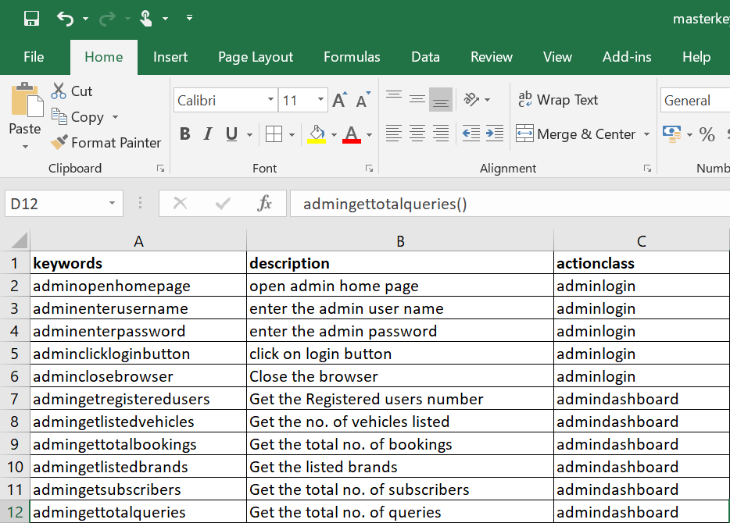

You can use the actionclass names as per the functionality of the keywords. For example adminopenhomepage, adminenterusername, adminenterpassword, adminclickloginbutton and adminclosebrowser are all belong to adminlogin class. I will write adminlogin class which constitute methods to perform the actions needed for these keywords.

Create a folder “data” and place this file under that folder.

Now we have the master keywords sheet.

Now write the individual test cases. The individual test cases contain mainly keywords and description of those keywords. I have developed one test case initially..

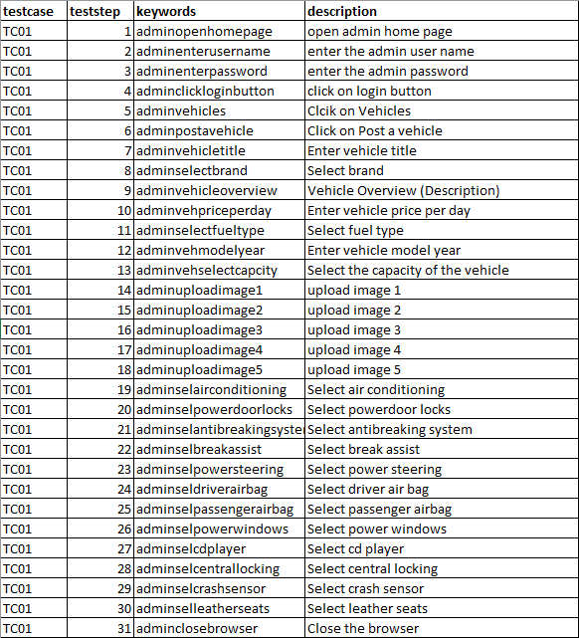

Name this file as tests_wb1 and the sheet name as TCGroup1.

Now develop the main test cases file.

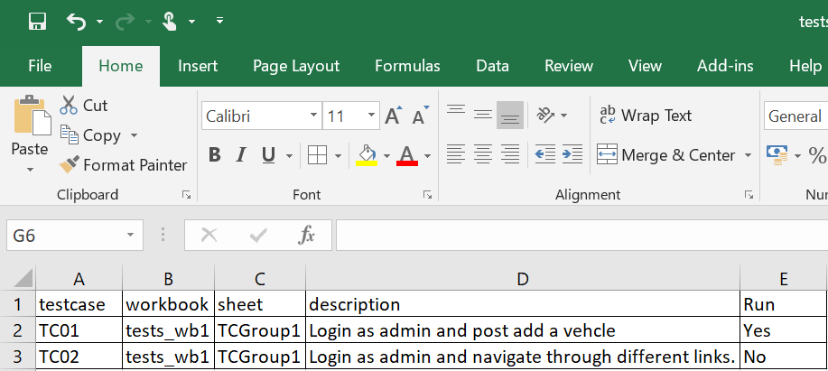

Here I have developed two tests. I mentioned the run mode for one test case as Yes and for the other as No, since I haven’t developed the second test case. Name this file as tests_main.xslx. Mentioned the workbook and sheet with the names given for the individual test steps file.

Now save these files under data folder under the project.